Name : مصطفي محمود عبدالواحد ابوالعنين

B.N : 935

Topic : artificial intelligence

GitHub link: <https://github.com/mustafa-mahmoud0/ECE001>

**Artificial intelligence:**

Artificial intelligence (AI) refers to the simulation of human intelligence in machines that are programmed to think like humans and mimic their actions. The term may also be applied to any machine that exhibits traits associated with a human mind such as learning and problem-solving.

The ideal characteristic of artificial intelligence is its ability to rationalize and take actions that have the best chance of achieving a specific goal.

Artificial intelligence is based on the principle that human intelligence can be defined in a way that a machine can easily mimic it and execute tasks, from the simplest to those that are even more complex. The goals of artificial intelligence include learning, reasoning, and perception.

Although AI has a strong science fiction connotation, it forms a vital branch of computer science, dealing with intelligent behavior, learning and adaptation in machines. Research in AI is concerned with producing machines to automate tasks requiring intelligent behavior. Examples include control, planning and scheduling, the ability to answer diagnostic and consumer questions, handwriting, speech, and facial recognition. As such, it has become a scientific discipline, focused on providing solutions to real life problems. AI systems are now in routine use in economics, medicine, engineering and the military, as well as being built into many common home computer software applications, traditional strategy games like computer chess and other video games.

Sorce code :

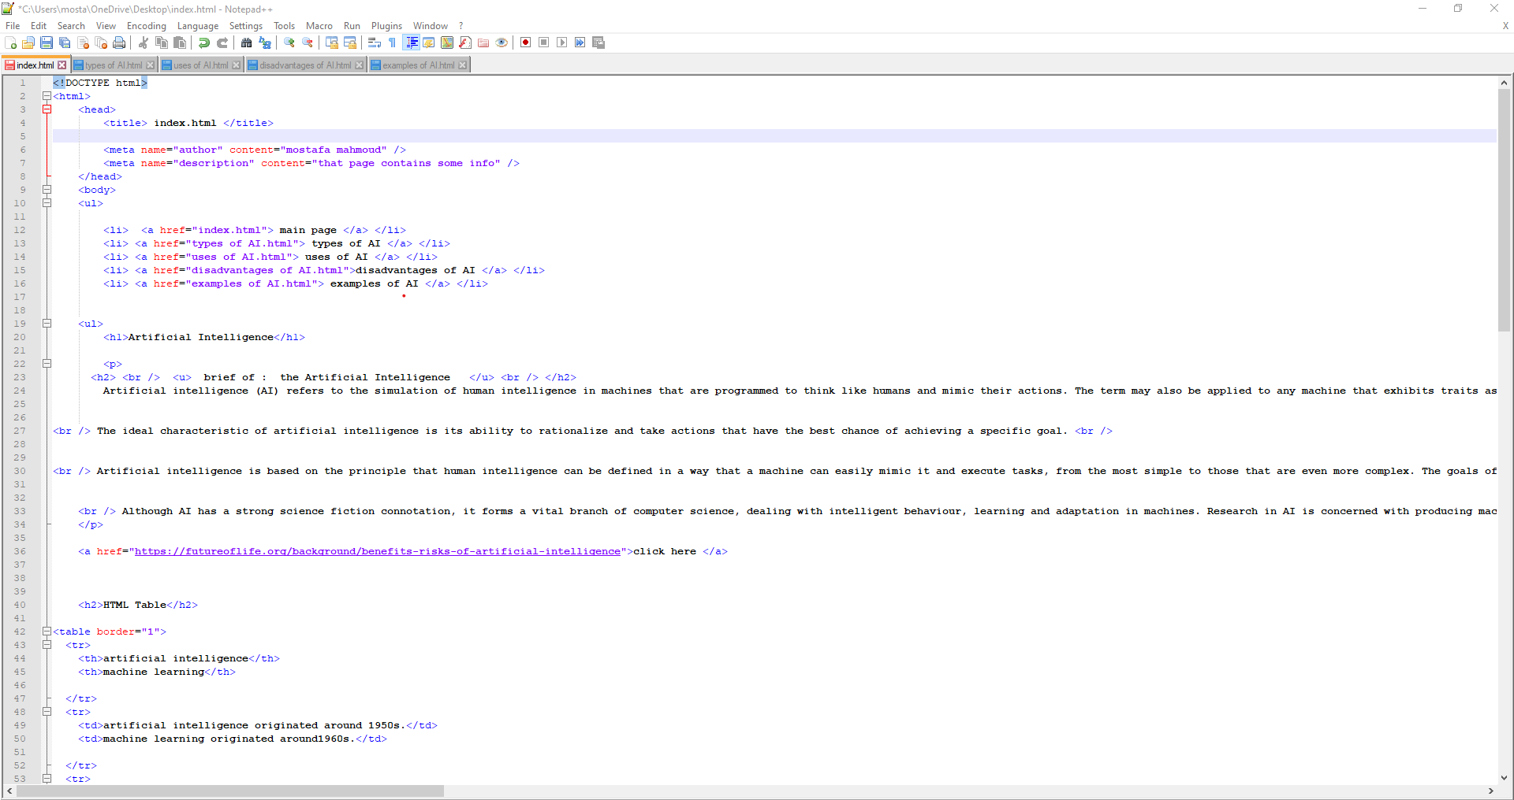

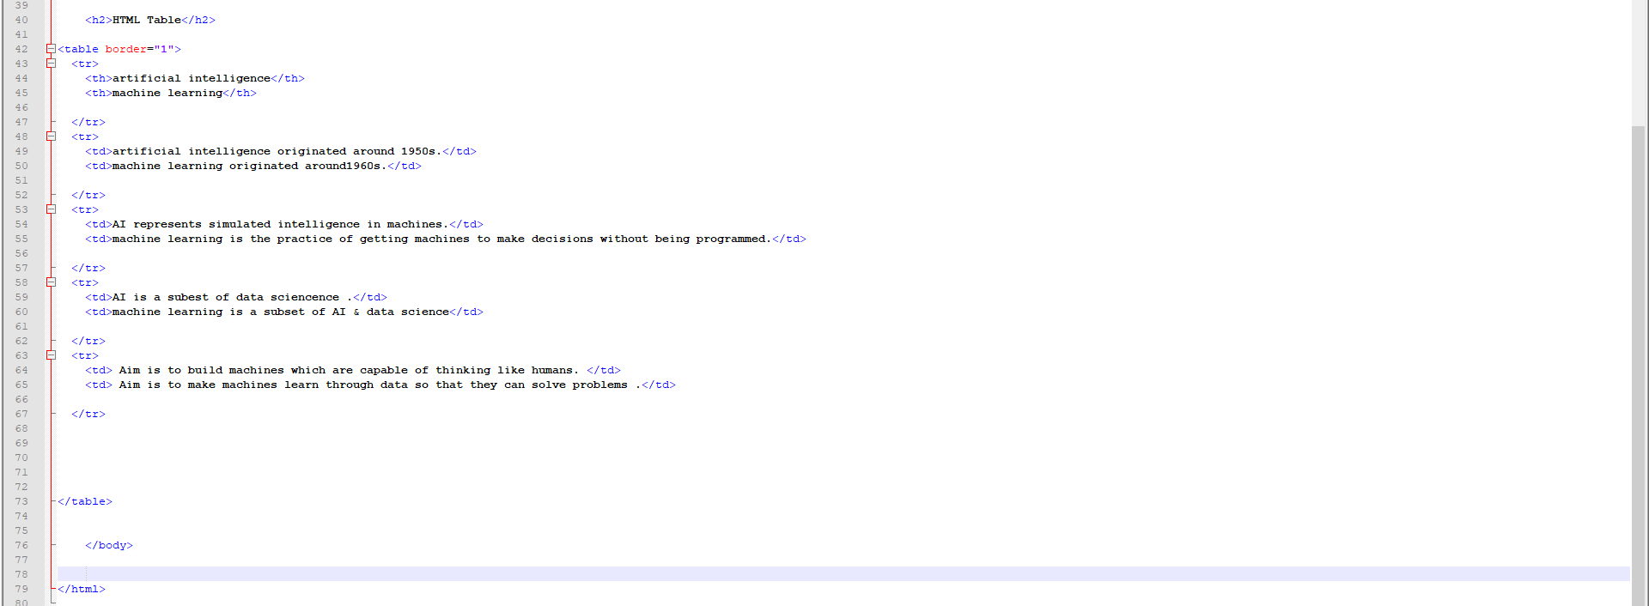

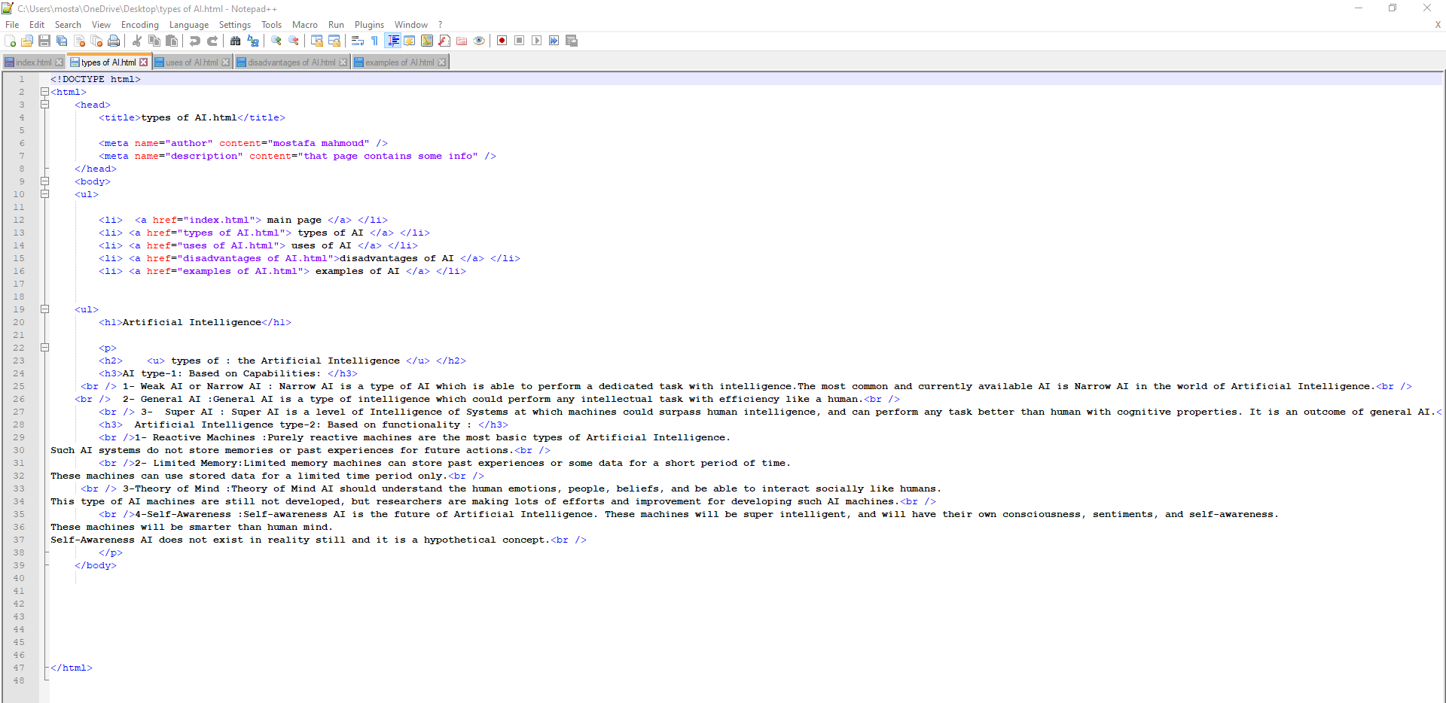

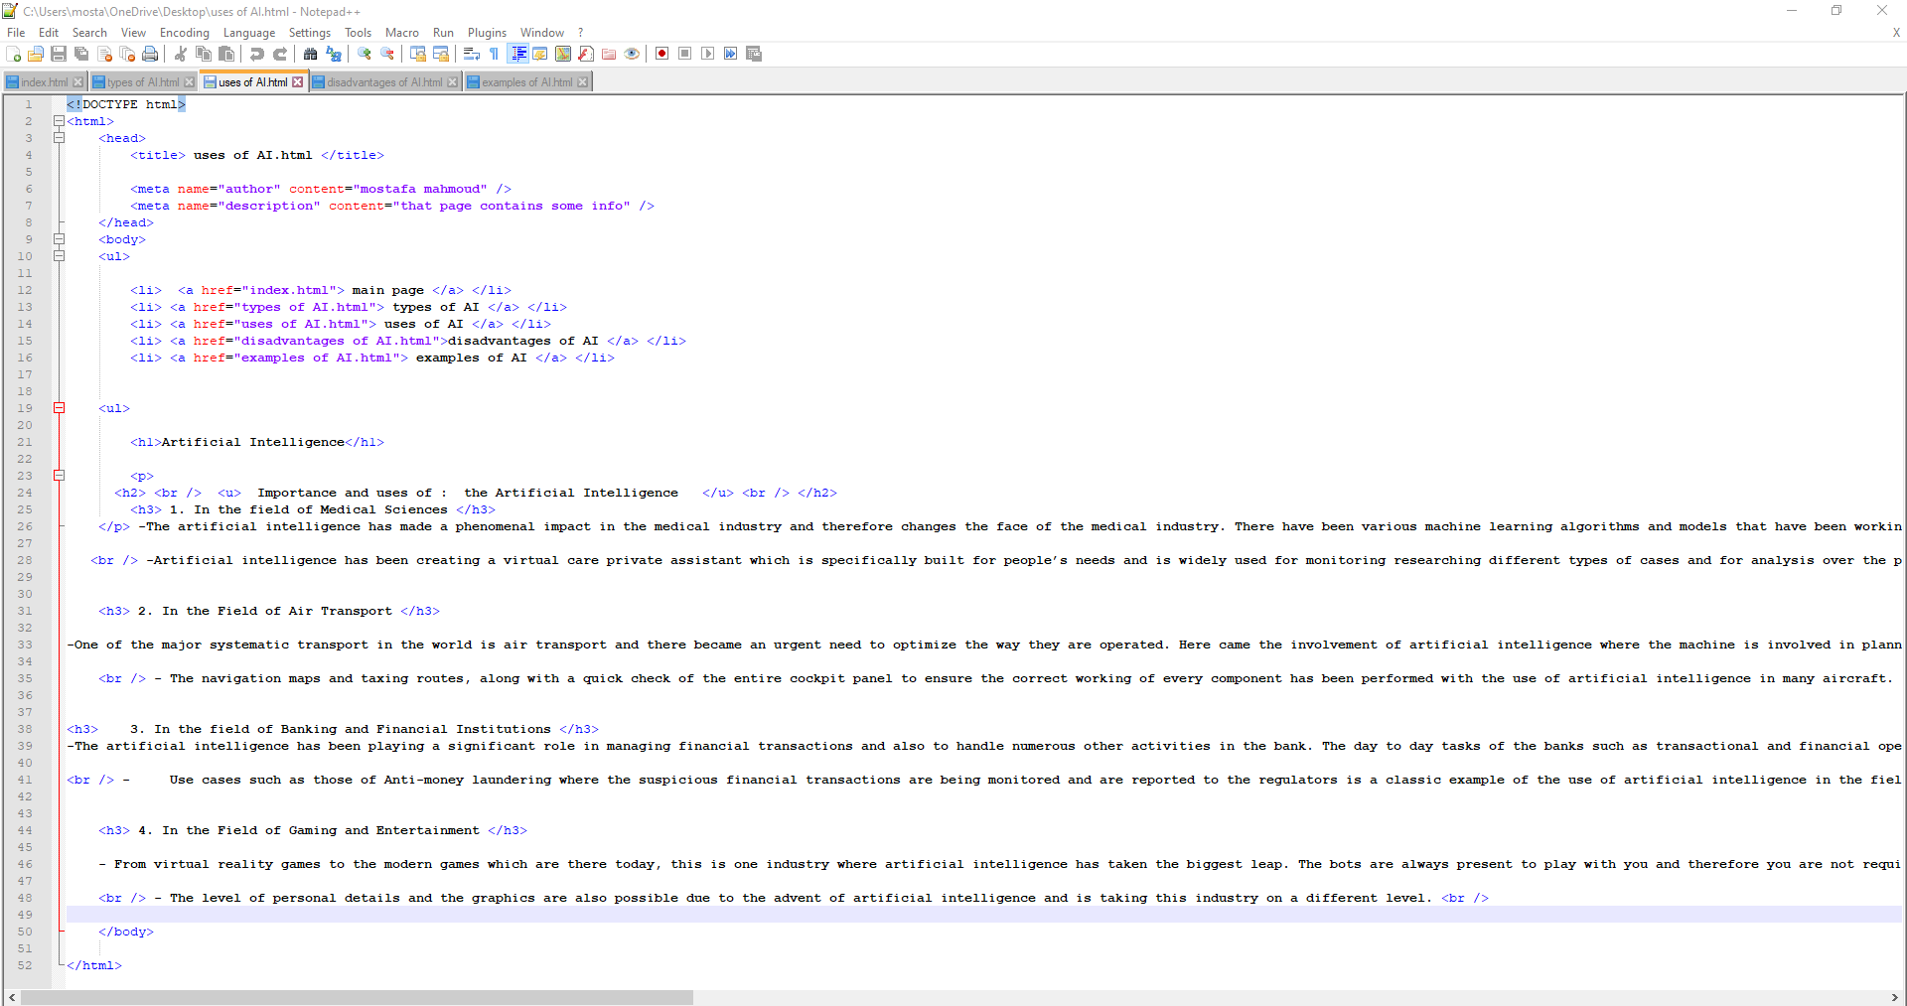

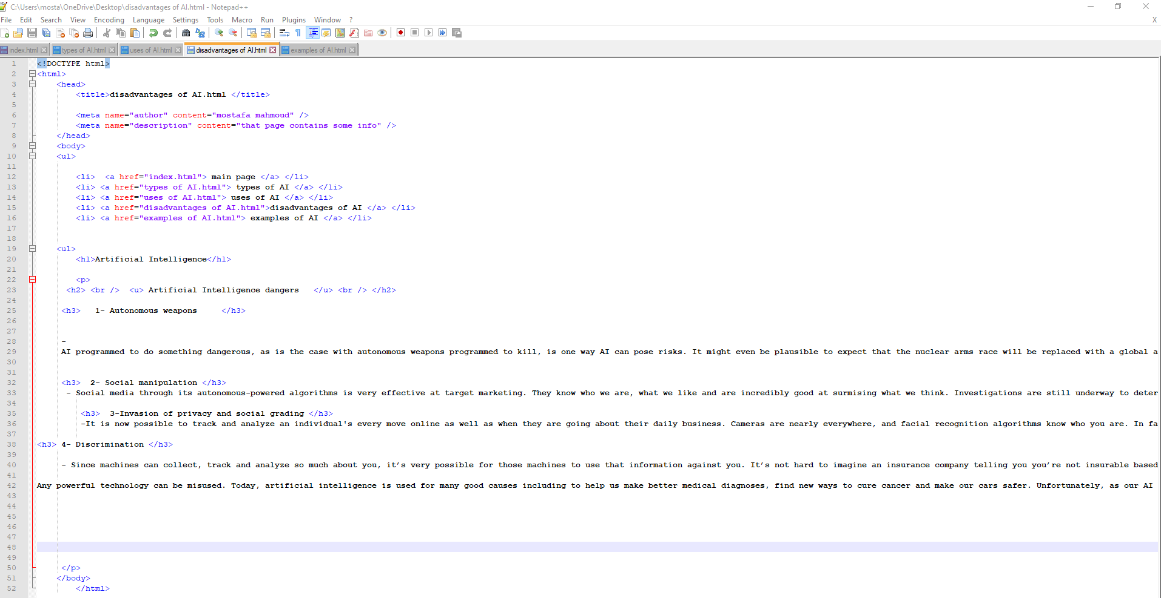

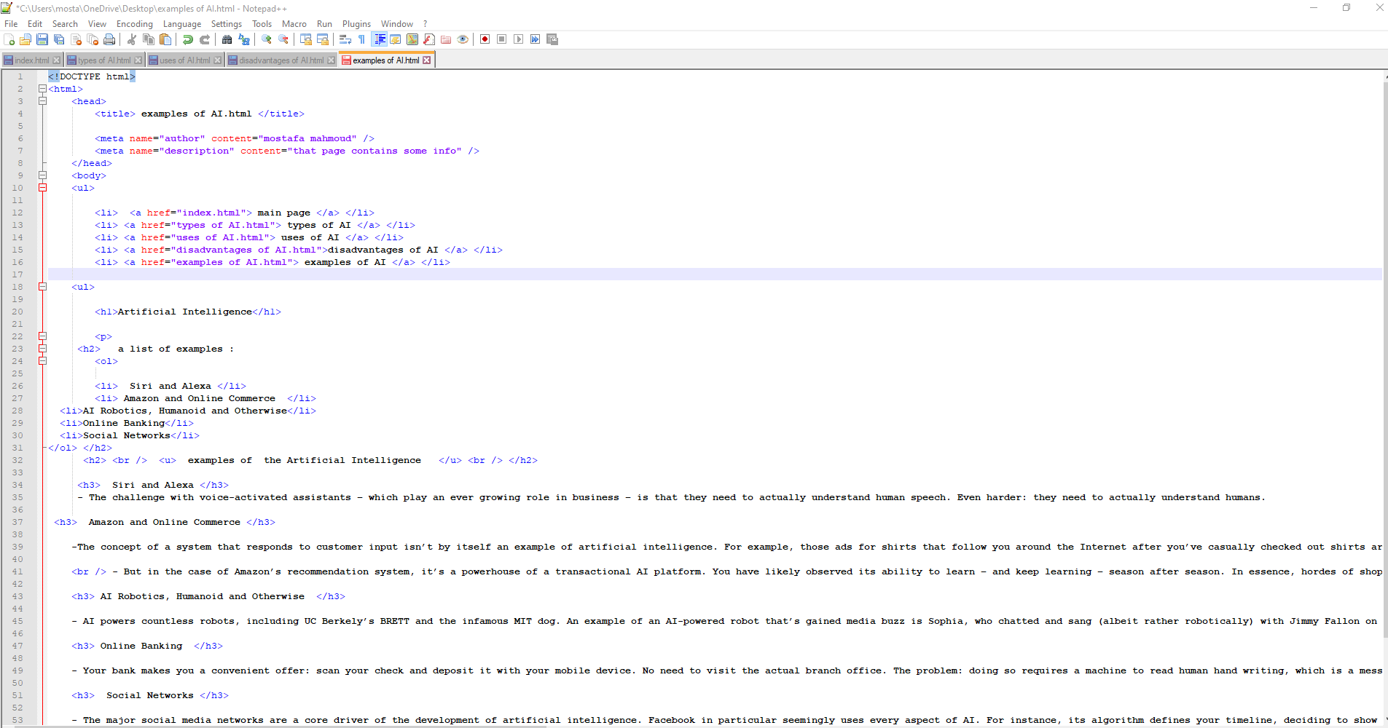

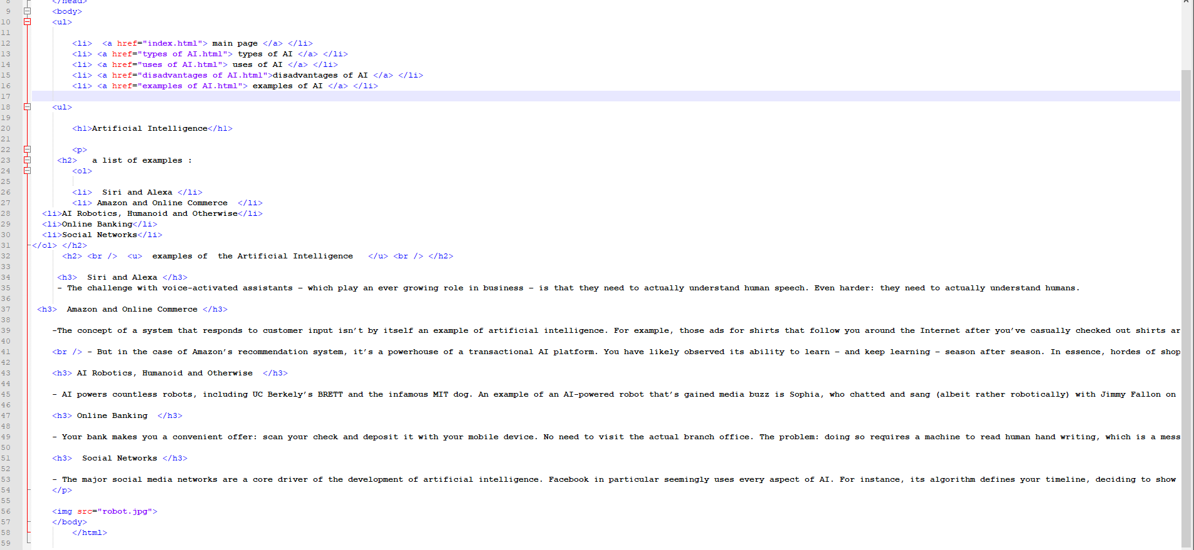

Screenshots :

